CHAPTER 8: The dynamic Earth
Worksheet 8.4

Earthquakes
Student: Class:

1. The following diagram shows a section of the Earth’s crust where an earthquake is being generated.
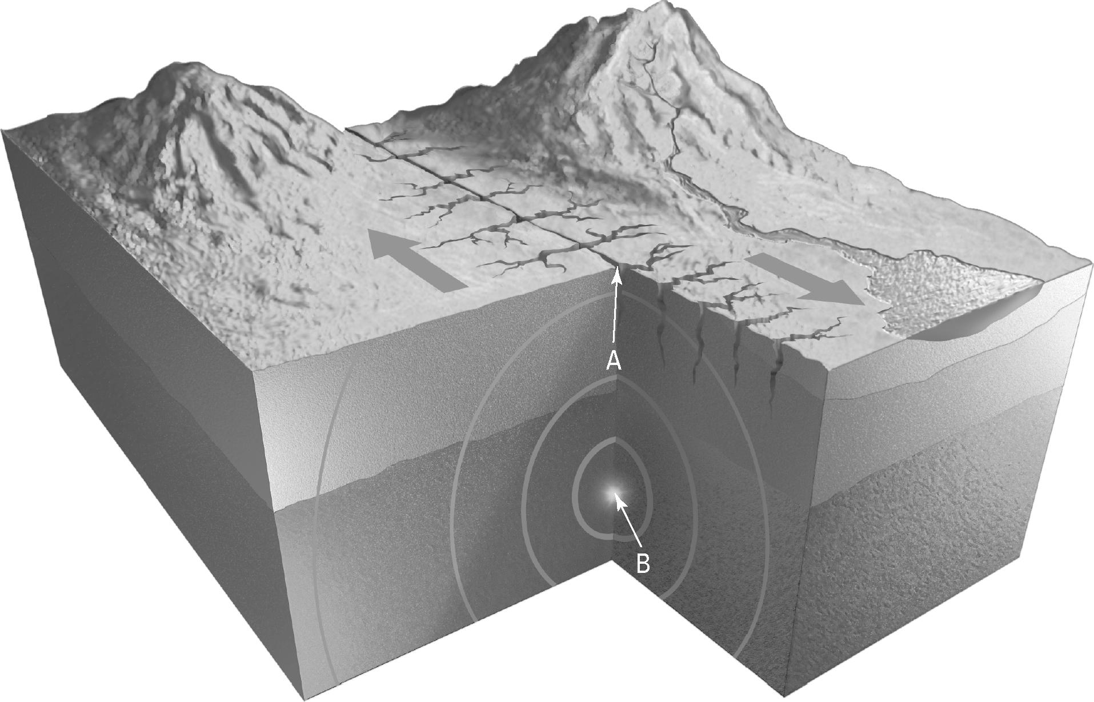
(a) Identify the points labelled A and B:

A:

B:
(b) Identify the likely cause of the earthquake illustrated.

(c) Australia does not experience many earthquakes. Explain.

CHAPTER 8: The dynamic Earth
Worksheet 8.4

Page 2

2. The following table provides information about earthquake intensities. The description information is jumbled. Use the letters G–L to match the Richter magnitude and the description of effects.
Richter magnitude | Description of effects
(A) 1.0 | (G) Causes serious damage over very large areas
(B) <3.5 | (H) Can be destructive over a 100 km wide area
(C) <6.0 | (I) Generally noticeable by humans
(D) 6.1–6.9 | (J) Can cause serious damage in areas several hundreds of km across
(E) 7.0–7.9 | (K) Undetectable by humans
(F) ≥8 | (L) Slight damage to well-designed buildings but can cause large cracks and material failure to poorly constructed buildings
A: ………………………….. B: ………………………….. C: …………………………..
D: ………………………….. E: ………………………….. F: …………………………...

3. The following diagram shows how a tsunami forms.
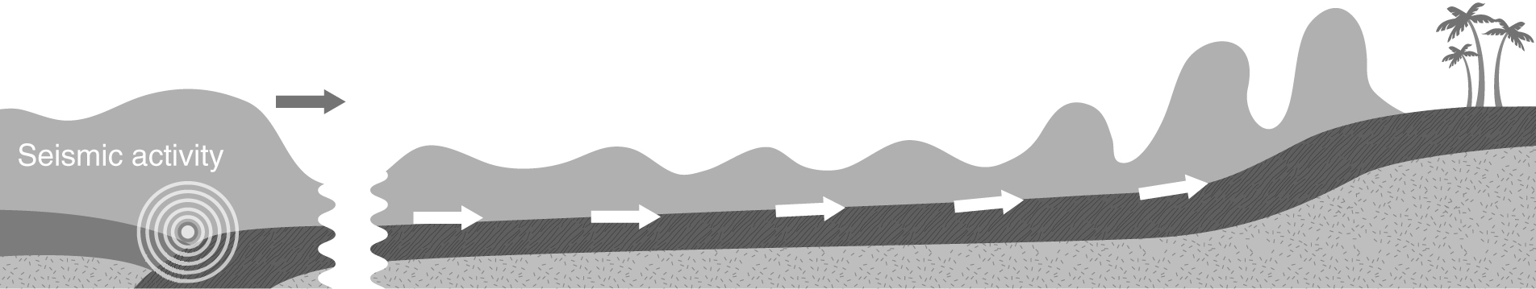

Explain why the height of the wave increases as it approaches the land.

